**Final Project Report**

**Shopper’s-hunt**

Devi Pranathi Vinturi

Department of Information Science

University of North Texas

INFO 5707: Data Modeling for Information Professionals

Jiankun Liu

May 03, 2023

**Objective:**

An objective for an e-commerce website could be to provide a convenient and user-friendly platform for customers to purchase products and services online. The website should aim to:

1. Increase sales and revenue by expanding the business to a wider audience.
2. Improve customer satisfaction by providing a seamless and secure shopping experience.
3. Build brand awareness and loyalty through effective marketing strategies.
4. Collect and analyze data to make informed business decisions.
5. Offer personalized recommendations and promotions based on customer behaviour.
6. Provide efficient and reliable customer support to enhance the overall experience.

**Scope:**

The scope of an e-commerce website could also include:

1. Integration with payment gateways and shipping carriers for seamless transactions and delivery.
2. Secure login and registration functionality to protect customer data and prevent fraud.
3. Advanced search capabilities and filtering options to improve product discovery.
4. Inventory management features to track stock levels and prevent overselling.
5. Analytics tools to monitor website traffic, sales performance, and customer behaviour.
6. Mobile-responsive design to provide a seamless experience across devices.

**User Requirements:**

1. Users should be able to browse products by category, brand, or search keywords.
2. Users should be able to view detailed information about each product, including images, descriptions, and customer reviews.
3. Users should be able to add products to a shopping cart and view the cart contents.
4. Users should be able to check out and make payments securely.
5. Users should be able to create and manage their accounts, including updating personal information, viewing order history, and tracking shipments.
6. Users should be able to easily contact customer support for assistance with orders, product inquiries, or technical issues.
7. Users should be able to leave feedback and ratings on products and the overall shopping experience.

**Business Rules:**

1. Products must have a unique SKU (stock-keeping unit) to help with inventory management.
2. Prices must be consistent across all channels (i.e., website, mobile app, physical store).
3. Shipping rates and delivery times must be clearly communicated to customers.
4. Payment processing must comply with PCI (Payment Card Industry) security standards.
5. Customer data must be protected in accordance with privacy laws and regulations.
6. All product descriptions, images, and pricing must be accurate and up-to-date to avoid misleading customers.
7. The website should comply with all relevant laws and regulations related to e-commerce, such as consumer protection, privacy, and data security.

8 entities that could be used to model an e-commerce website:

1. Customer - This entity would include information such as name, email, shipping address, billing address, and payment method. It could also include additional fields for tracking customer behavior and preferences.
2. Product - This entity would include information such as product name, description, price, SKU, and inventory levels. It could also include fields for product categories, brands, and reviews.
3. Order - This entity would include information such as order number, order date, customer ID, and payment information. It could also include fields for order status, shipping information, and discounts.
4. Cart - This entity would include information such as customer ID, product ID, quantity, and price. It would be used to track the items currently in a customer's shopping cart.
5. Category - This entity would include information such as category name, description, and parent category (if applicable). It would be used to organize products and facilitate browsing.
6. Brand - This entity would include information such as brand name, description, and logo. It would be used to identify and promote products from specific brands.
7. Review - This entity would include information such as product ID, customer ID, rating, and review text. It would be used to collect and display customer feedback on products.
8. Order_details: This entity represents a specific instance of a product being ordered as part of an order. It includes information about the quantity and price of the product in that order. The "order_id" and "product_id" foreign keys allow the order detail to be linked to the specific order and product it corresponds to.
9. Admin - This entity would include information such as username, password, and permissions. It would be used to control access to the website's backend and manage product, order, and customer data.

**Shopper’s-hunt E-R Diagram**

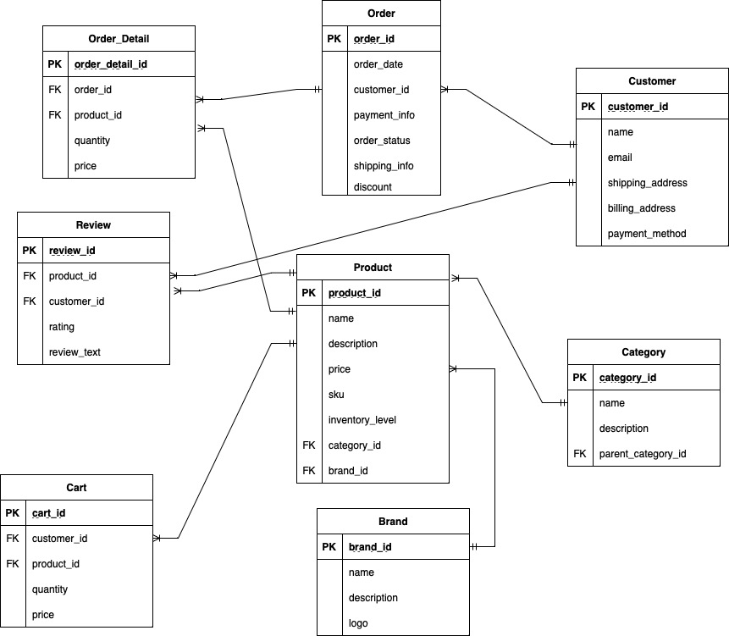

**DATA DICTIONARY**



**Data Entry and Update**

create database ecc;

use ecc;

CREATE TABLE Brand (

brand_id INT PRIMARY KEY,

name VARCHAR(255),

description TEXT,

logo VARCHAR(255)

);

CREATE TABLE Category (

category_id INT PRIMARY KEY,

name VARCHAR(255),

description TEXT,

parent_category_id INT,

FOREIGN KEY (parent_category_id) REFERENCES Category(category_id)

);

CREATE TABLE Customer (

customer_id INT PRIMARY KEY,

name VARCHAR(255),

email VARCHAR(255),

shipping_address VARCHAR(255),

billing_address VARCHAR(255),

payment_method VARCHAR(255)

);

CREATE TABLE Product (

product_id INT PRIMARY KEY,

name VARCHAR(255),

description TEXT,

price DECIMAL(10,2),

sku VARCHAR(255),

inventory_level INT,

category_id INT,

brand_id INT,

FOREIGN KEY (category_id) REFERENCES Category(category_id),

FOREIGN KEY (brand_id) REFERENCES Brand(brand_id)

);

CREATE TABLE Orders (

order_id INT PRIMARY KEY,

order_date DATE,

customer_id INT,

payment_info TEXT,

order_status VARCHAR(255),

shipping_info TEXT,

discount DECIMAL(10,2),

FOREIGN KEY (customer_id) REFERENCES Customer(customer_id)

);

CREATE TABLE Order_Detail (

order_detail_id INT PRIMARY KEY,

order_id INT,

product_id INT,

quantity INT,

price DECIMAL(10,2),

FOREIGN KEY (order_id) REFERENCES Orders(order_id),

FOREIGN KEY (product_id) REFERENCES Product(product_id)

);

CREATE TABLE Cart (

cart_id INT PRIMARY KEY,

customer_id INT,

product_id INT,

quantity INT,

price DECIMAL(10,2),

FOREIGN KEY (customer_id) REFERENCES Customer(customer_id),

FOREIGN KEY (product_id) REFERENCES Product(product_id)

);

CREATE TABLE Review (

review_id INT PRIMARY KEY,

product_id INT,

customer_id INT,

rating INT,

review_text TEXT,

FOREIGN KEY (product_id) REFERENCES Product(product_id),

FOREIGN KEY (customer_id) REFERENCES Customer(customer_id)

);

CREATE TABLE Admin (

admin_id INT PRIMARY KEY,

username VARCHAR(255),

password VARCHAR(255),

permissions VARCHAR(255)

);

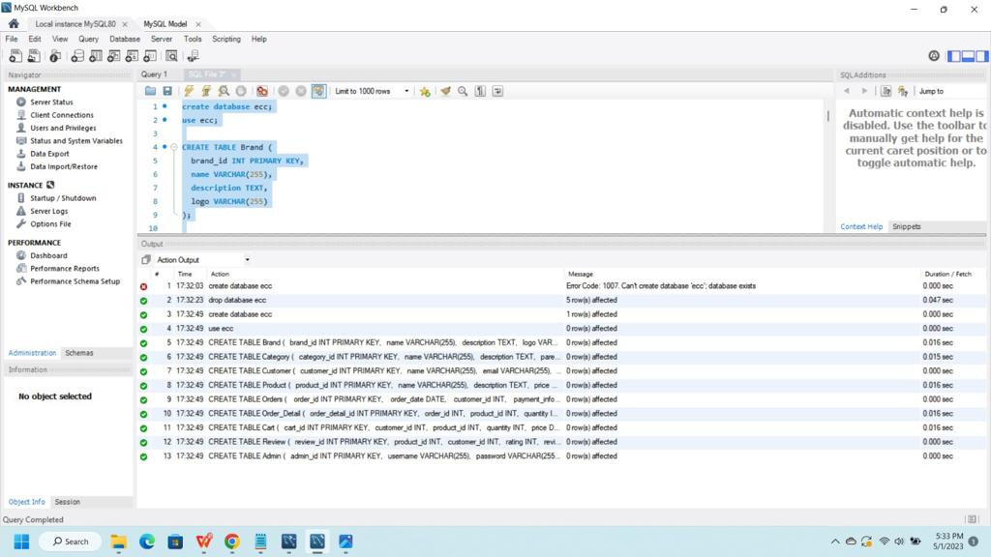

-- Insert data into Brand table

INSERT INTO Brand (brand_id, name, description, logo) VALUES

(1, 'Nike', 'Sportswear brand', 'https://www.example.com/nike.png'),

(2, 'Adidas', 'Sportswear brand', 'https://www.example.com/adidas.png'),

(3, 'Apple', 'Technology company', 'https://www.example.com/apple.png'),

(4, 'Samsung', 'Technology company', 'https://www.example.com/samsung.png'),

(5, 'Coca-Cola', 'Beverage company', 'https://www.example.com/coca-cola.png'),

(6, 'Pepsi', 'Beverage company', 'https://www.example.com/pepsi.png'),

(7, 'Ford', 'Automobile company', 'https://www.example.com/ford.png'),

(8, 'Toyota', 'Automobile company', 'https://www.example.com/toyota.png'),

(9, 'Gucci', 'Luxury fashion brand', 'https://www.example.com/gucci.png'),

(10, 'Prada', 'Luxury fashion brand', 'https://www.example.com/prada.png'),

(11, 'Lululemon', 'Athletic apparel brand', 'https://www.example.com/lululemon.png'),

(12, 'Under Armour', 'Athletic apparel brand', 'https://www.example.com/underarmour.png'),

(13, 'Microsoft', 'Technology company', 'https://www.example.com/microsoft.png'),

(14, 'Google', 'Technology company', 'https://www.example.com/google.png'),

(15, 'Amazon', 'E-commerce company', 'https://www.example.com/amazon.png');

-- Insert data into Category table

INSERT INTO Category (category_id, name, description, parent_category_id) VALUES

(1, 'Electronics', 'Electronics products', NULL),

(2, 'Clothing', 'Apparel products', NULL),

(3, 'Shoes', 'Footwear products', 2),

(4, 'Accessories', 'Apparel accessories', 2),

(5, 'Smartphones', 'Smartphone devices', 1),

(6, 'Tablets', 'Tablet devices', 1),

(7, 'Laptops', 'Laptop devices', 1),

(8, 'Desktops', 'Desktop computer devices', 1),

(9, 'Sneakers', 'Sneaker shoes', 3),

(10, 'Sandals', 'Sandal shoes', 3),

(11, 'Boots', 'Boot shoes', 3),

(12, 'Bags', 'Fashion bags', 4),

(13, 'Hats', 'Fashion hats', 4),

(14, 'Watches', 'Fashion watches', 4),

(15, 'Jewelry', 'Fashion jewelry', 4);

INSERT INTO Customer (customer_id, name, email, shipping_address, billing_address, payment_method) VALUES

(1, 'John Doe', 'john.doe@example.com', '123 Main St, Anytown USA', '123 Main St, Anytown USA', 'Credit Card'),

(2, 'Jane Smith', 'jane.smith@example.com', '456 Elm St, Anytown USA', '456 Elm St, Anytown USA', 'PayPal'),

(3, 'Bob Johnson', 'bob.johnson@example.com', '789 Oak St, Anytown USA', '789 Oak St, Anytown USA', 'Credit Card'),

(4, 'Alice Lee', 'alice.lee@example.com', '321 Pine St, Anytown USA', '321 Pine St, Anytown USA', 'Credit Card'),

(5, 'Mark Davis', 'mark.davis@example.com', '654 Birch St, Anytown USA', '654 Birch St, Anytown USA', 'PayPal'),

(6, 'Emily Chen', 'emily.chen@example.com', '987 Cedar St, Anytown USA', '987 Cedar St, Anytown USA', 'Credit Card'),

(7, 'Tom Smith', 'tom.smith@example.com', '654 Elm St, Anytown USA', '654 Elm St, Anytown USA', 'PayPal'),

(8, 'Lisa Kim', 'lisa.kim@example.com', '321 Oak St, Anytown USA', '321 Oak St, Anytown USA', 'Credit Card'),

(9, 'David Johnson', 'david.johnson@example.com', '789 Pine St, Anytown USA', '789 Pine St, Anytown USA', 'PayPal'),

(10, 'Sarah Lee', 'sarah.lee@example.com', '123 Birch St, Anytown USA', '123 Birch St, Anytown USA', 'Credit Card'),

(11, 'Chris Davis', 'chris.davis@example.com', '987 Cedar St, Anytown USA', '987 Cedar St, Anytown USA', 'PayPal'),

(12, 'Amy Chen', 'amy.chen@example.com', '654 Elm St, Anytown USA', '654 Elm St, Anytown USA', 'Credit Card'),

(13, 'Kevin Smith', 'kevin.smith@example.com', '321 Oak St, Anytown USA', '321 Oak St, Anytown USA', 'PayPal'),

(14, 'Michelle Kim', 'michelle.kim@example.com', '789 Pine St, Anytown USA', '789 Pine St, Anytown USA', 'Credit Card'),

(15, 'Brian Johnson', 'brian.johnson@example.com', '123 Birch St, Anytown USA', '123 Birch St, Anytown USA', 'PayPal')

INSERT INTO Product (product_id, name, description, price, sku, inventory_level, category_id, brand_id) VALUES

(1, 'Widget A', 'A great widget', 9.99, 'WID-A', 100, 1, 1),

(2, 'Widget B', 'An even better widget', 19.99, 'WID-B', 50, 1, 2),

(3, 'Gadget C', 'A useful gadget', 29.99, 'GAD-C', 25, 2, 1),

(4, 'Tool D', 'A handy tool', 14.99, 'TOO-D', 75, 3, 2),

(5, 'Accessory E', 'A stylish accessory', 49.99, 'ACC-E', 30, 4, 1),

(6, 'Gizmo F', 'A fun gizmo', 9.99, 'GIZ-F', 100, 2, 3),

(7, 'Widget G', 'A colorful widget', 7.99, 'WID-G', 150, 1, 2),

(8, 'Tool H', 'A durable tool', 24.99, 'TOO-H', 50, 3, 1),

(9, 'Accessory I', 'A versatile accessory', 34.99, 'ACC-I', 40, 4, 2),

(10, 'Gadget J', 'A sleek gadget', 44.99, 'GAD-J', 20, 2, 1),

(11, 'Widget K', 'A unique widget', 11.99, 'WID-K', 120, 1, 3),

(12, 'Tool L', 'A precise tool', 29.99, 'TOO-L', 60, 3, 2),

(13, 'Gizmo M', 'A trendy gizmo', 16.99, 'GIZ-M', 80, 2, 1),

(14, 'Accessory N', 'A functional accessory', 39.99, 'ACC-N', 35, 4, 3),

(15, 'Gadget O', 'An advanced gadget', 79.99, 'GAD-O', 15, 2, 2);

INSERT INTO Orders (order_id, order_date, customer_id, payment_info, order_status, shipping_info, discount)

VALUES

(1, '2022-01-01', 1, 'Credit Card', 'Pending', 'Standard', 0),

(2, '2022-01-02', 2, 'PayPal', 'Shipped', 'Priority', 5.00),

(3, '2022-01-03', 3, 'Cash On Delivery', 'Delivered', 'Standard', 0),

(4, '2022-01-04', 4, 'Credit Card', 'Pending', 'Standard', 0),

(5, '2022-01-05', 5, 'PayPal', 'Shipped', 'Priority', 2.50),

(6, '2022-01-06', 6, 'Cash On Delivery', 'Delivered', 'Standard', 0),

(7, '2022-01-07', 7, 'Credit Card', 'Pending', 'Standard', 0),

(8, '2022-01-08', 8, 'PayPal', 'Shipped', 'Priority', 10.00),

(9, '2022-01-09', 9, 'Cash On Delivery', 'Delivered', 'Standard', 0),

(10, '2022-01-10', 10, 'Credit Card', 'Pending', 'Standard', 0),

(11, '2022-01-11', 11, 'PayPal', 'Shipped', 'Priority', 7.50),

(12, '2022-01-12', 12, 'Cash On Delivery', 'Delivered', 'Standard', 0),

(13, '2022-01-13', 13, 'Credit Card', 'Pending', 'Standard', 0),

(14, '2022-01-14', 14, 'PayPal', 'Shipped', 'Priority', 12.50),

(15, '2022-01-15', 15, 'Cash On Delivery', 'Delivered', 'Standard', 0);

INSERT INTO Order_Detail (order_detail_id, order_id, product_id, quantity, price)

VALUES

(1, 1, 1, 2, 19.98),

(2, 1, 2, 1, 19.99),

(3, 1, 3, 3, 89.97),

(4, 2, 1, 1, 9.99),

(5, 2, 2, 2, 39.98),

(6, 2, 3, 1, 29.99),

(7, 3, 4, 2, 49.98),

(8, 3, 5, 1, 9.99),

(9, 3, 6, 1, 14.99),

(10, 4, 7, 1, 12.99),

(11, 4, 8, 3, 59.97),

(12, 5, 9, 2, 39.98),

(13, 5, 10, 1, 19.99),

(14, 5, 11, 1, 24.99),

(15, 5, 12, 1, 9.99);

INSERT INTO Cart (cart_id, customer_id, product_id, quantity, price)

VALUES

(1, 5, 2, 2, 39.98),

(2, 3, 4, 1, 14.99),

(3, 1, 1, 3, 29.97),

(4, 2, 6, 2, 19.98),

(5, 4, 8, 1, 79.99),

(6, 1, 10, 2, 49.98),

(7, 2, 11, 1, 4.99),

(8, 3, 3, 1, 29.99),

(9, 5, 14, 3, 149.97),

(10, 4, 5, 2, 39.98),

(11, 2, 12, 1, 9.99),

(12, 1, 9, 1, 19.99),

(13, 3, 7, 1, 11.99),

(14, 5, 15, 2, 59.98),

(15, 4, 13, 1, 29.99);

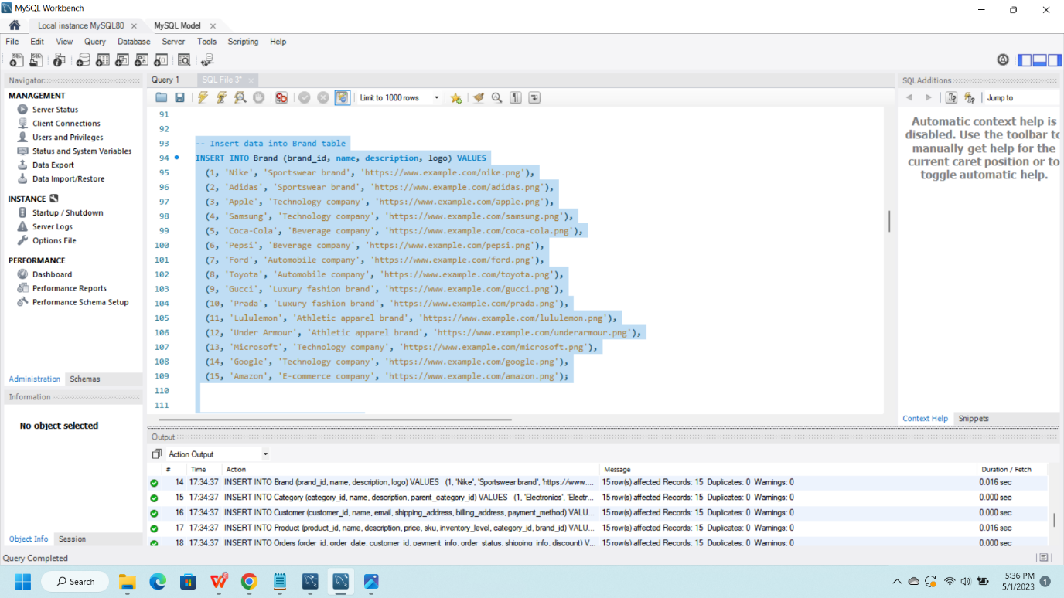

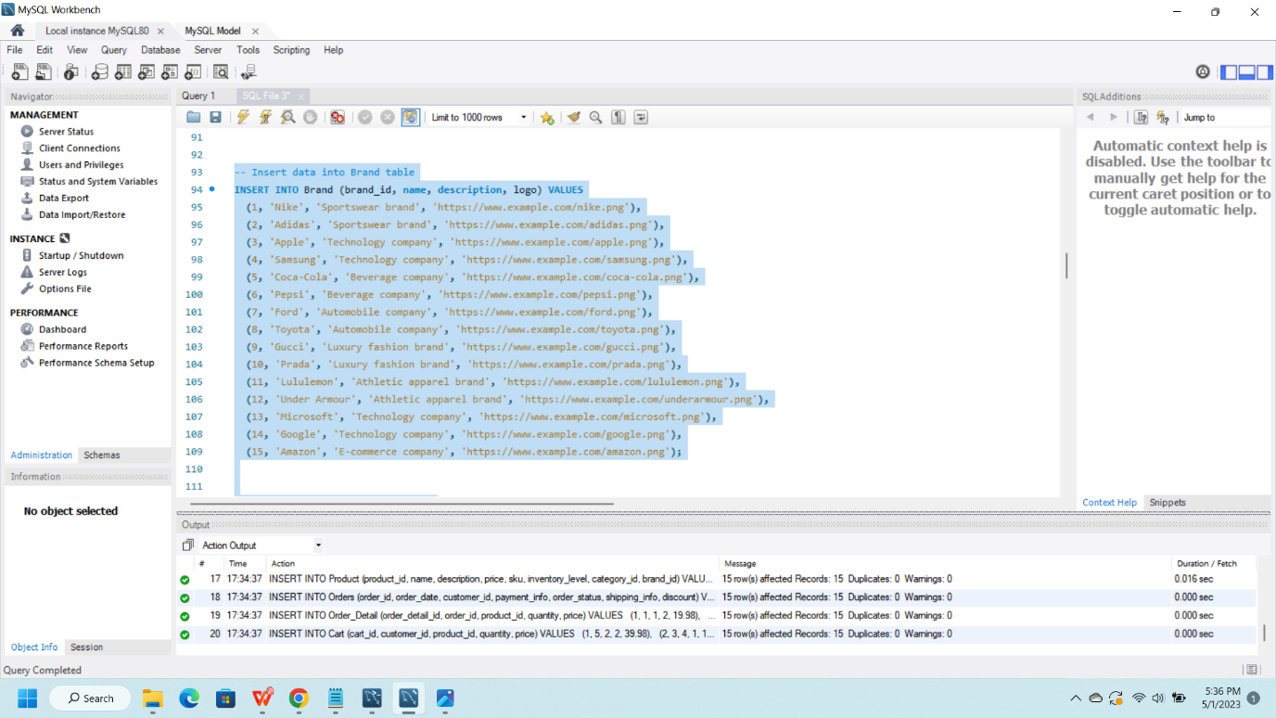

**Data Retrieval and Simple Reports**

SELECT name, description, price

FROM Product

WHERE category_id = 1;

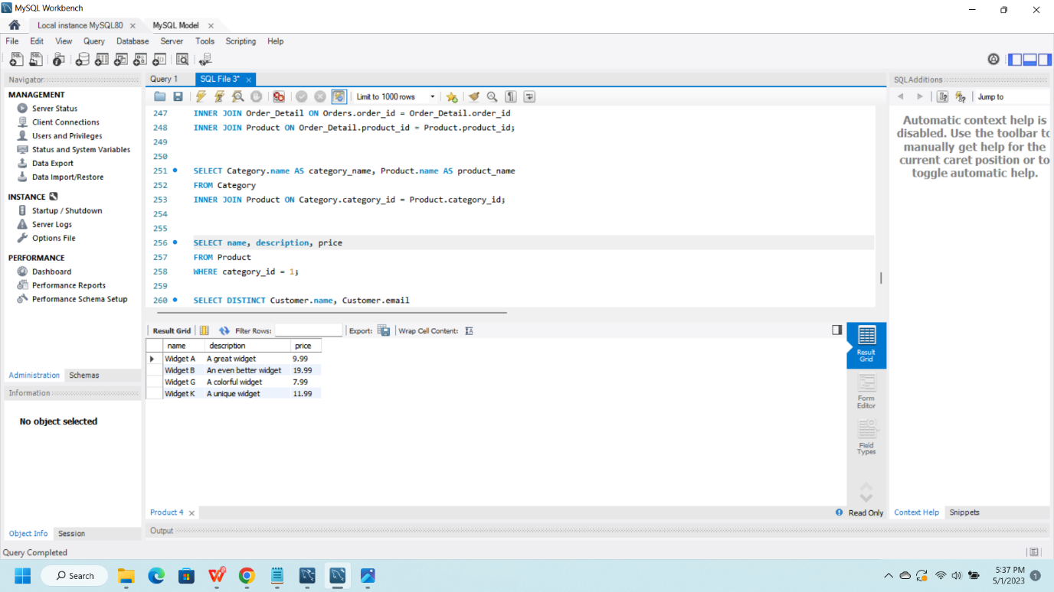

SELECT Category.name AS category_name, Product.name AS product_name

FROM Category

INNER JOIN Product ON Category.category_id = Product.category_id;

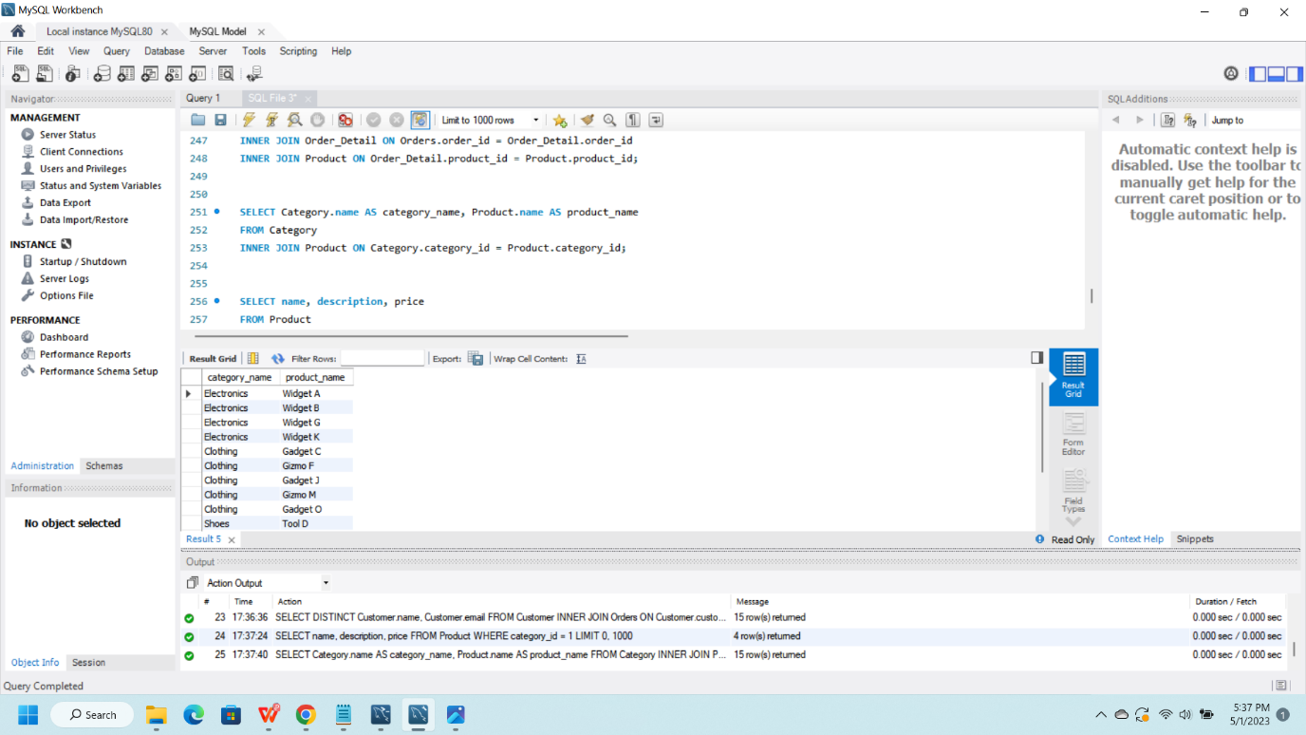

SELECT Orders.order_id, Orders.order_date, Product.name, Order_Detail.quantity, Order_Detail.price

FROM Orders

INNER JOIN Order_Detail ON Orders.order_id = Order_Detail.order_id

INNER JOIN Product ON Order_Detail.product_id = Product.product_id;

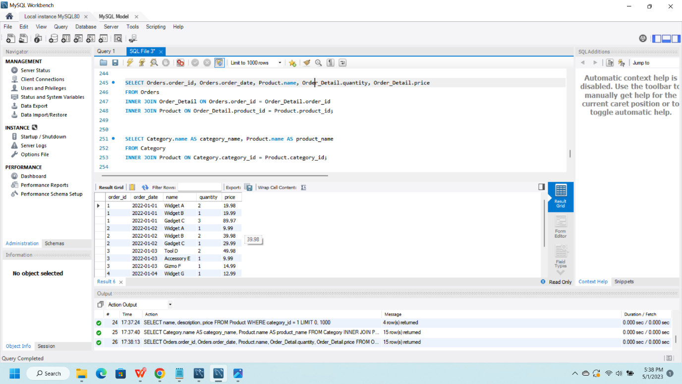

SELECT name, inventory_level

FROM Product;

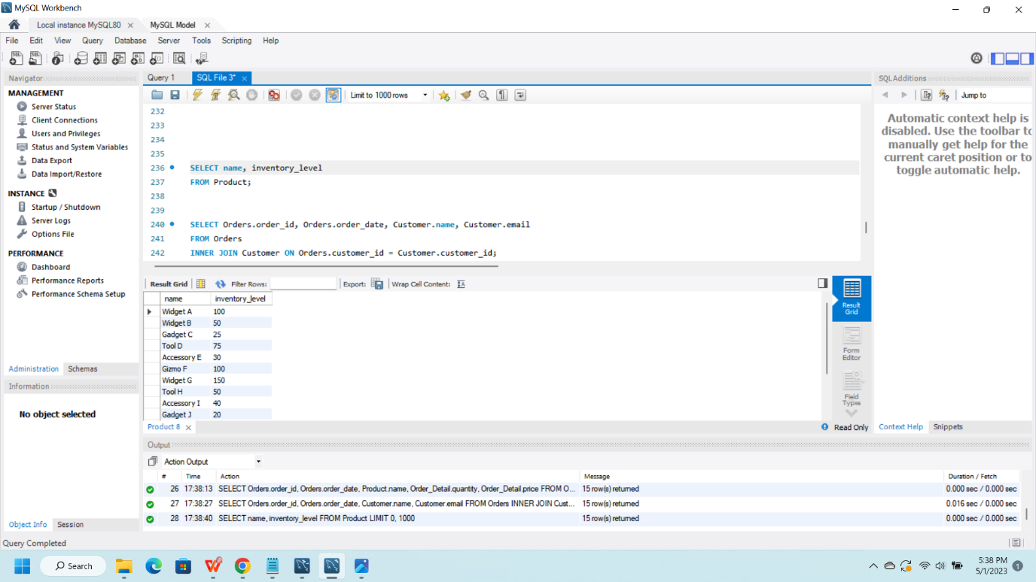

SELECT Orders.order_id, Orders.order_date, Customer.name, Customer.email

FROM Orders

INNER JOIN Customer ON Orders.customer_id = Customer.customer_id;

